**CIT 352 Chapter 6**

Name: Celeste George

Project 6-1

Any version of Ubuntu Server 20.04 LTS will do (e.g. Ubuntu Server 20.04.4 LTS)

Step 9b: Insert the screen capture

Project 6-2

Step 2: This is where you would add SATA disks



Step 5: Typo

[Original]

mdadm --create /dev/md0 --level=5 --raid-devices=4 /dev/sdb /dev/sdc /dev/sdd /dev/sdd --verbose

[Corrected]

mdadm --create /dev/md0 --level=5 --raid-devices=4 /dev/sdb /dev/sdc /dev/sdd /dev/sd**e** --verbose

Step 12: Why is it not 4GB (4 x 1GB disks)?

The space of the drive is not large.

Step 18: Insert the screen capture

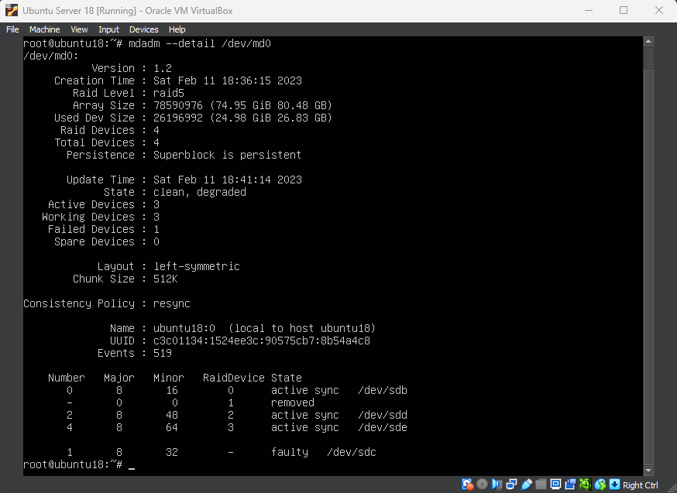

Project 6-3

Step 17: Insert the screen capture that shows the quota and compression configurations have been set according to the instruction.

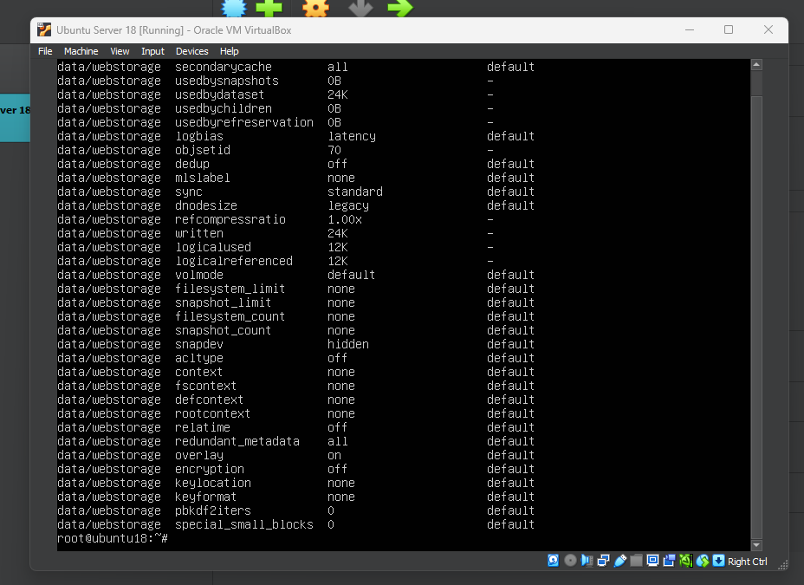

Project 6-4

Step 3: Missing instruction

[Original]

At the command prompt, type ...

[Corrected]

Type **mkdir /data** to create a mount point. At the command prompt, type ...

Step 16: Insert the screen capture

Project 6-5

Step 9. What are the files within these directories?

Amd 64-micro-blacklist.conf

Blacklist-ath_Pci.conf

blacklist.conf

Project 6-6

Step 9: Typo

[Original] mount -t proc proc /proc

[Updated] mount -t proc /proc /mnt/proc

Step 11: What warning did you receive regarding the Secret123 password?

Bad pass: the password fails the dictionary check.

Project 6-7

The ISO image is available at <http://releases.ubuntu.com/14.04/>. Choose “64-bit PC (AMD64) server install image” for download.

Step 26: Insert the screen capture

**Command Reference**

Vi /etc/modules-load.d/modules.conf

Less /var/log/syslog

Btrfs device add

Btrfs subvolumne create

Mount -o subvol=archive,compress=lzo /dev/sdb /archive